MAPPING STORE PROCEDURE

CREATE OR REPLACE PROCEDURE MAPPING_PARTA AS

Dim OSS_TIME_DIM%ROWTYPE;

InnerJoinStatement varchar2(1000);

TableMax number;

TableCounter number := 1;

TableCounterr number := 2;

ParentNo number;

DescNo number;

BEGIN

FOR i IN 0..3 LOOP

EXECUTE IMMEDIATE ('DROP TABLE OSS_TIME_DIM_'||i);

END LOOP;

FOR I IN 0..3 LOOP

TableMax := I + 2;

ParentNo := I + 1;

DescNo:= I + 2;

InnerJoinStatement := InnerJoinStatement ||

'CREATE TABLE OSS_TIME_DIM_'||I||' AS

(

SELECT hc1.time_key,

hc1.time_level,

hc'||ParentNo||'.parent_id,

hc'||DescNo||'.time_desc

FROM OSS_TIME_DIM HC'||TableCounter;

WHILE (TableCounter < TableMax) LOOP

TableCounterr := TableCounter + 1;

InnerJoinStatement := InnerJoinStatement ||

' INNER JOIN OSS_TIME_DIM HC'||TableCounterr||

' ON (hc'||TableCounter||'.parent_id = hc'||TableCounterr||'.time_key)';

TableCounter := TableCounter + 1;

END LOOP;

TableCounter := 1;

EXECUTE IMMEDIATE (InnerJoinStatement || ')');

InnerJoinStatement := '';

END LOOP;

END MAPPING_PARTA;

PartA Execute

CREATE TABLE OSS_TIME_DIM_0(time_id varchar2(4));

CREATE TABLE OSS_TIME_DIM_1(time_id varchar2(4));

CREATE TABLE OSS_TIME_DIM_2(time_id varchar2(4));

CREATE TABLE OSS_TIME_DIM_3(time_id varchar2(4));

execute MAPPING_PARTA();

SELECT * FROM OSS_TIME_DIM_0;

SELECT * FROM OSS_TIME_DIM_1;

SELECT * FROM OSS_TIME_DIM_2;

SELECT * FROM OSS_TIME_DIM_3;

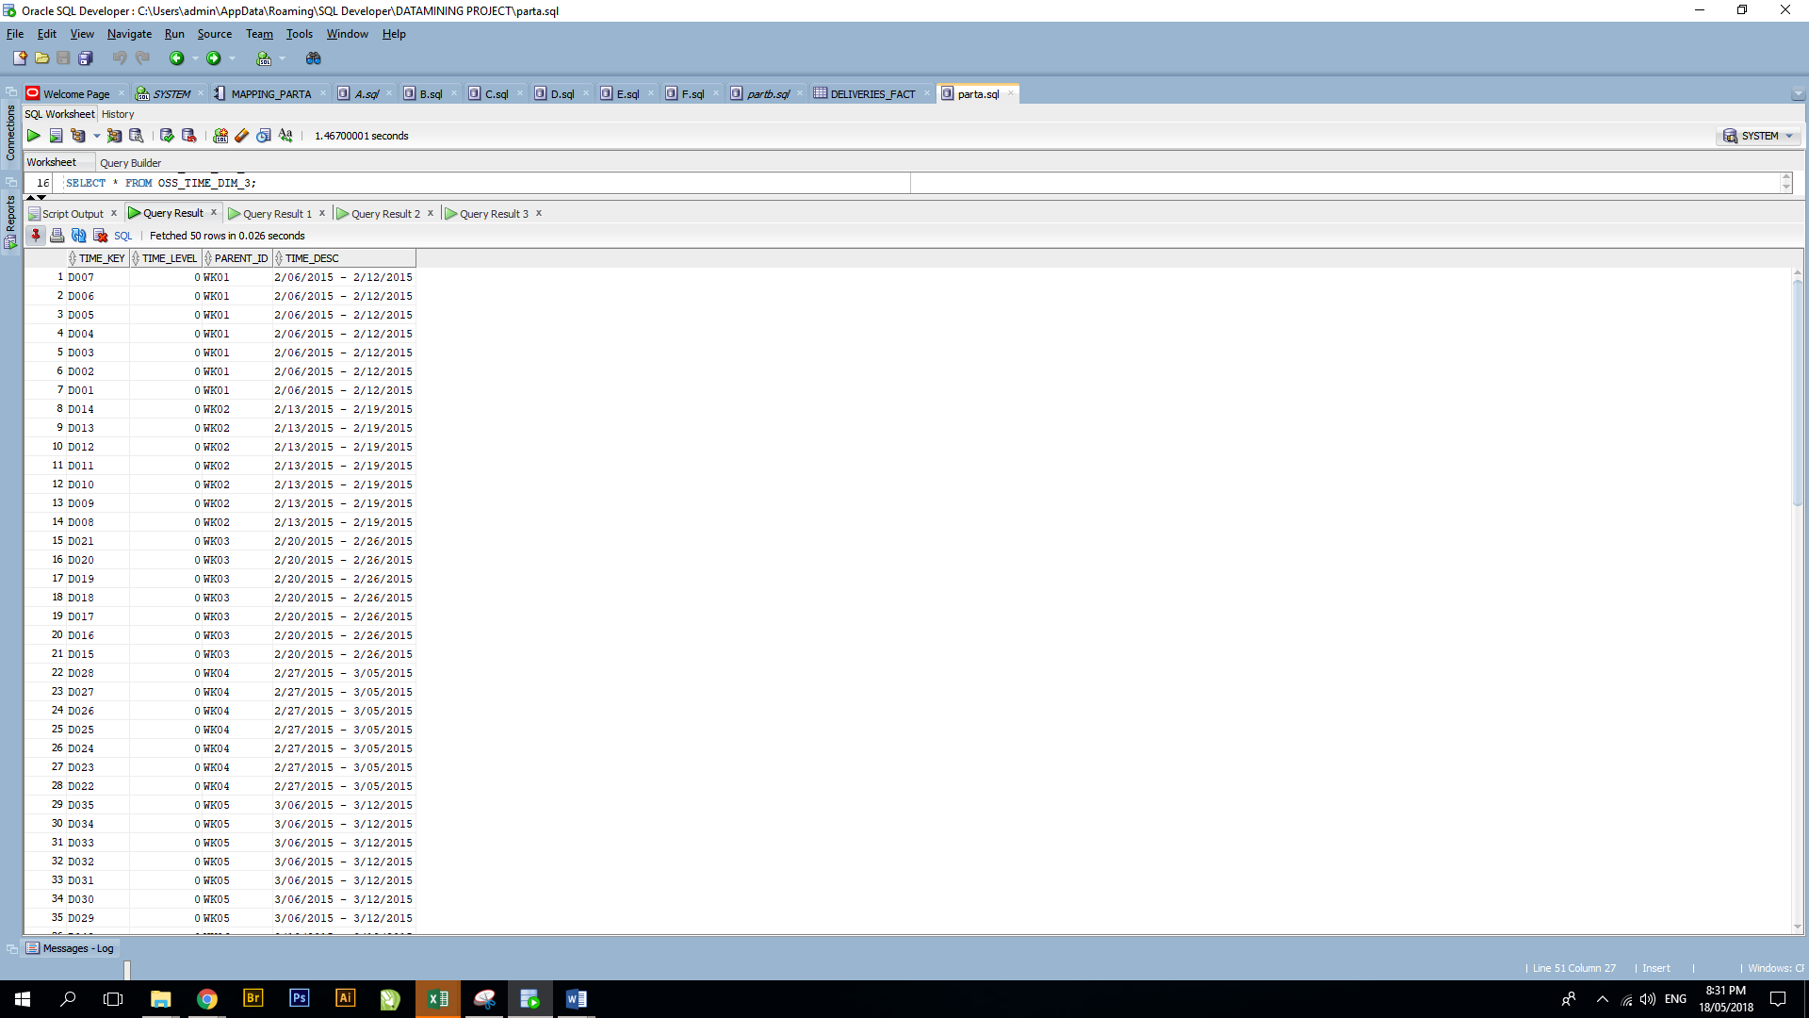

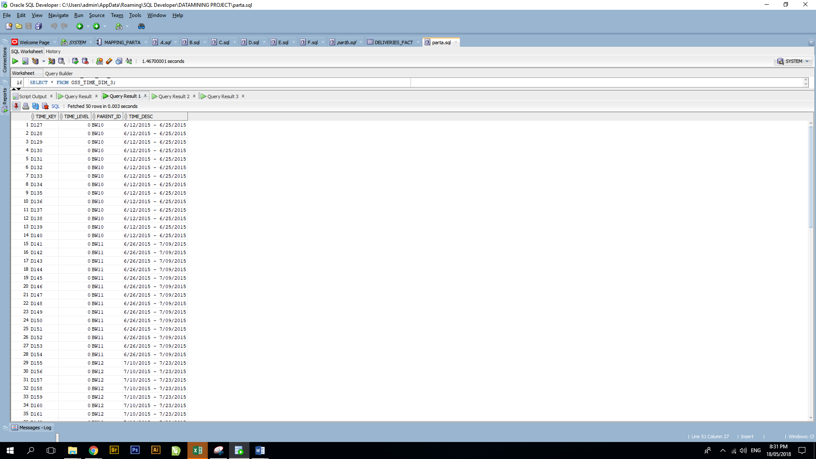

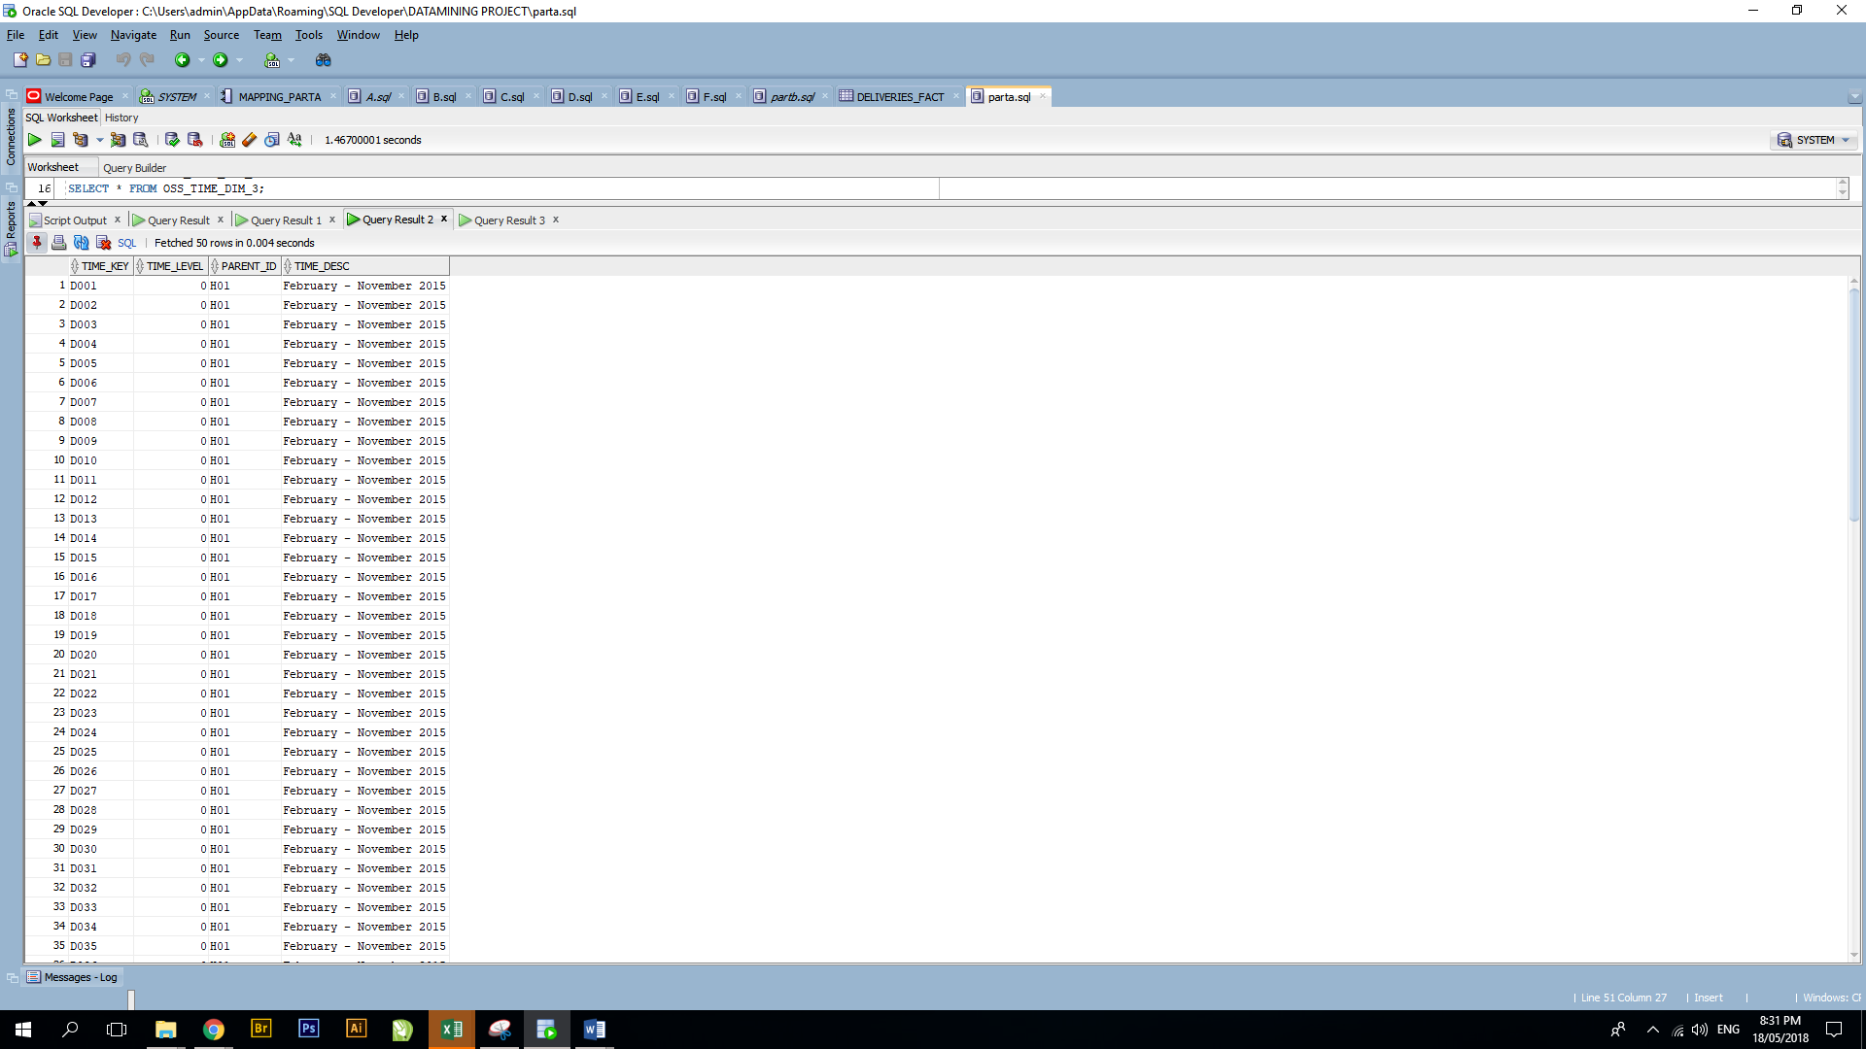

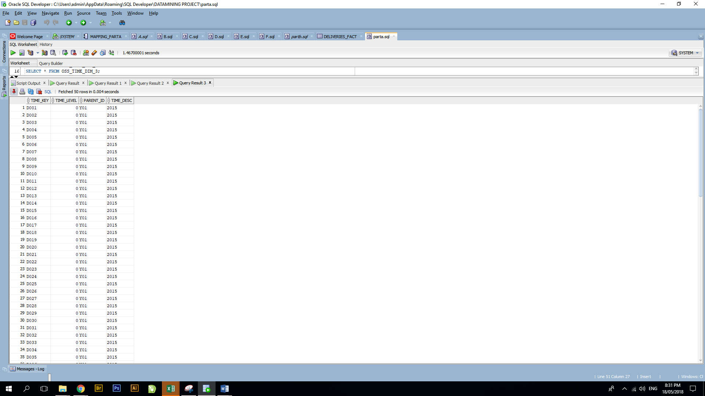

DELIVERIES_FACT

set serveroutput on

DECLARE

CURSOR SS IS

SELECT *

FROM SUPER_STORE;

CURSOR HC IS

SELECT *

FROM OSS_TIME_DIM

ORDER BY time_id DESC;

CURSOR HC0 IS

SELECT *

FROM OSS_TIME_DIM_0;

CURSOR HC1 IS

SELECT *

FROM OSS_TIME_DIM_1;

CURSOR HC2 IS

SELECT *

FROM OSS_TIME_DIM_2;

CURSOR HC3 IS

SELECT *

FROM OSS_TIME_DIM_3;

Dim OSS_TIME_DIM%ROWTYPE;

Dim0 OSS_TIME_DIM_0%ROWTYPE;

Dim1 OSS_TIME_DIM_1%ROWTYPE;

Dim2 OSS_TIME_DIM_2%ROWTYPE;

Dim3 OSS_TIME_DIM_3%ROWTYPE;

ssds SUPER_STORE%ROWTYPE;

BEGIN

EXECUTE IMMEDIATE ('DROP TABLE DELIVERIES_FACT');

EXECUTE IMMEDIATE ('CREATE TABLE DELIVERIES_FACT AS (

SELECT *

FROM SUPER_STORE)');

EXECUTE IMMEDIATE ('ALTER TABLE DELIVERIES_FACT

ADD Da varchar2(10)');

EXECUTE IMMEDIATE ('ALTER TABLE DELIVERIES_FACT

ADD WK varchar2(10)');

EXECUTE IMMEDIATE ('ALTER TABLE DELIVERIES_FACT

ADD BW varchar2(10)');

EXECUTE IMMEDIATE ('ALTER TABLE DELIVERIES_FACT

ADD Mo varchar2(10)');

EXECUTE IMMEDIATE ('ALTER TABLE DELIVERIES_FACT

ADD Qu varchar2(10)');

EXECUTE IMMEDIATE ('ALTER TABLE DELIVERIES_FACT

ADD HY varchar2(10)');

EXECUTE IMMEDIATE ('ALTER TABLE DELIVERIES_FACT

ADD Ye varchar2(10)');

OPEN HC;

LOOP

FETCH HC INTO Dim;

-- EXIT WHEN (Dim.TIME_LEVEL = 2);

EXIT WHEN HC%NOTFOUND;

-- dbms_output.put_line('UPDATE DELIVERIES_FACT

-- SET Ye='''||Dim.time_key||'''

-- WHERE ship_date LIKE ''%'||Dim.time_desc||'''');

IF (Dim.time_level = 6) THEN

dbms_output.put_line('after LEVEL 6');

EXECUTE IMMEDIATE ('UPDATE DELIVERIES_FACT

SET Ye='''||Dim.time_key||'''

WHERE ship_date LIKE ''%'||Dim.time_desc||'''');

ELSIF (Dim.time_level = 5) THEN

dbms_output.put_line('after LEVEL 5');

EXECUTE IMMEDIATE ('UPDATE DELIVERIES_FACT

SET HY='''||Dim.time_key||'''

WHERE Ye='''||Dim.parent_id||'''');

ELSIF (Dim.time_level = 4) THEN

dbms_output.put_line('after LEVEL 4');

EXECUTE IMMEDIATE ('UPDATE DELIVERIES_FACT

SET Qu='''||Dim.time_key||'''

WHERE HY='''||Dim.parent_id||'''');

ELSIF (Dim.time_level = 3) THEN

dbms_output.put_line('after LEVEL 3');

EXECUTE IMMEDIATE ('UPDATE DELIVERIES_FACT

SET Mo='''||Dim.time_key||'''

WHERE Qu='''||Dim.parent_id||'''');

ELSIF (Dim.time_level = 0) THEN

-- dbms_output.put_line('after LEVEL 0');

EXECUTE IMMEDIATE ('UPDATE DELIVERIES_FACT

SET Da='''||Dim.time_key||'''

WHERE ship_date='''||Dim.time_desc||'''');

END IF;

END LOOP;

dbms_output.put_line('after exit');

CLOSE HC;

OPEN HC0;

LOOP

FETCH HC0 INTO Dim0;

EXIT WHEN HC0%NOTFOUND;

IF (Dim0.parent_id LIKE '%M%') THEN

EXECUTE IMMEDIATE ('UPDATE DELIVERIES_FACT

SET Mo='''||Dim0.parent_id||'''

WHERE Da='''||Dim0.time_key||'''');

ELSIF (Dim0.parent_id LIKE '%WK%') THEN

EXECUTE IMMEDIATE ('UPDATE DELIVERIES_FACT

SET Wk='''||Dim0.parent_id||'''

WHERE Da='''||Dim0.time_key||'''');

END IF;

END LOOP;

CLOSE HC0;

OPEN HC1;

LOOP

FETCH HC1 INTO Dim1;

EXIT WHEN HC1%NOTFOUND;

IF (Dim1.parent_id LIKE '%BW%') THEN

EXECUTE IMMEDIATE ('UPDATE DELIVERIES_FACT

SET Bw='''||Dim1.parent_id||'''

WHERE Da='''||Dim1.time_key||'''');

END IF;

END LOOP;

CLOSE HC1;

OPEN HC2;

LOOP

FETCH HC2 INTO Dim2;

EXIT WHEN HC2%NOTFOUND;

IF (Dim2.parent_id LIKE '%BW%') THEN

EXECUTE IMMEDIATE ('UPDATE DELIVERIES_FACT

SET Ho='''||Dim2.parent_id||'''

WHERE Da='''||Dim2.time_key||'''');

END IF;

END LOOP;

CLOSE HC2;

OPEN HC3;

LOOP

FETCH HC3 INTO Dim3;

EXIT WHEN HC3%NOTFOUND;

IF (Dim3.parent_id LIKE '%BW%') THEN

EXECUTE IMMEDIATE ('UPDATE DELIVERIES_FACT

SET Bw='''||Dim3.parent_id||'''

WHERE Da='''||Dim3.time_key||'''');

END IF;

END LOOP;

CLOSE HC3;

END;

/

SELECT * FROM DELIVERIES_FACT;

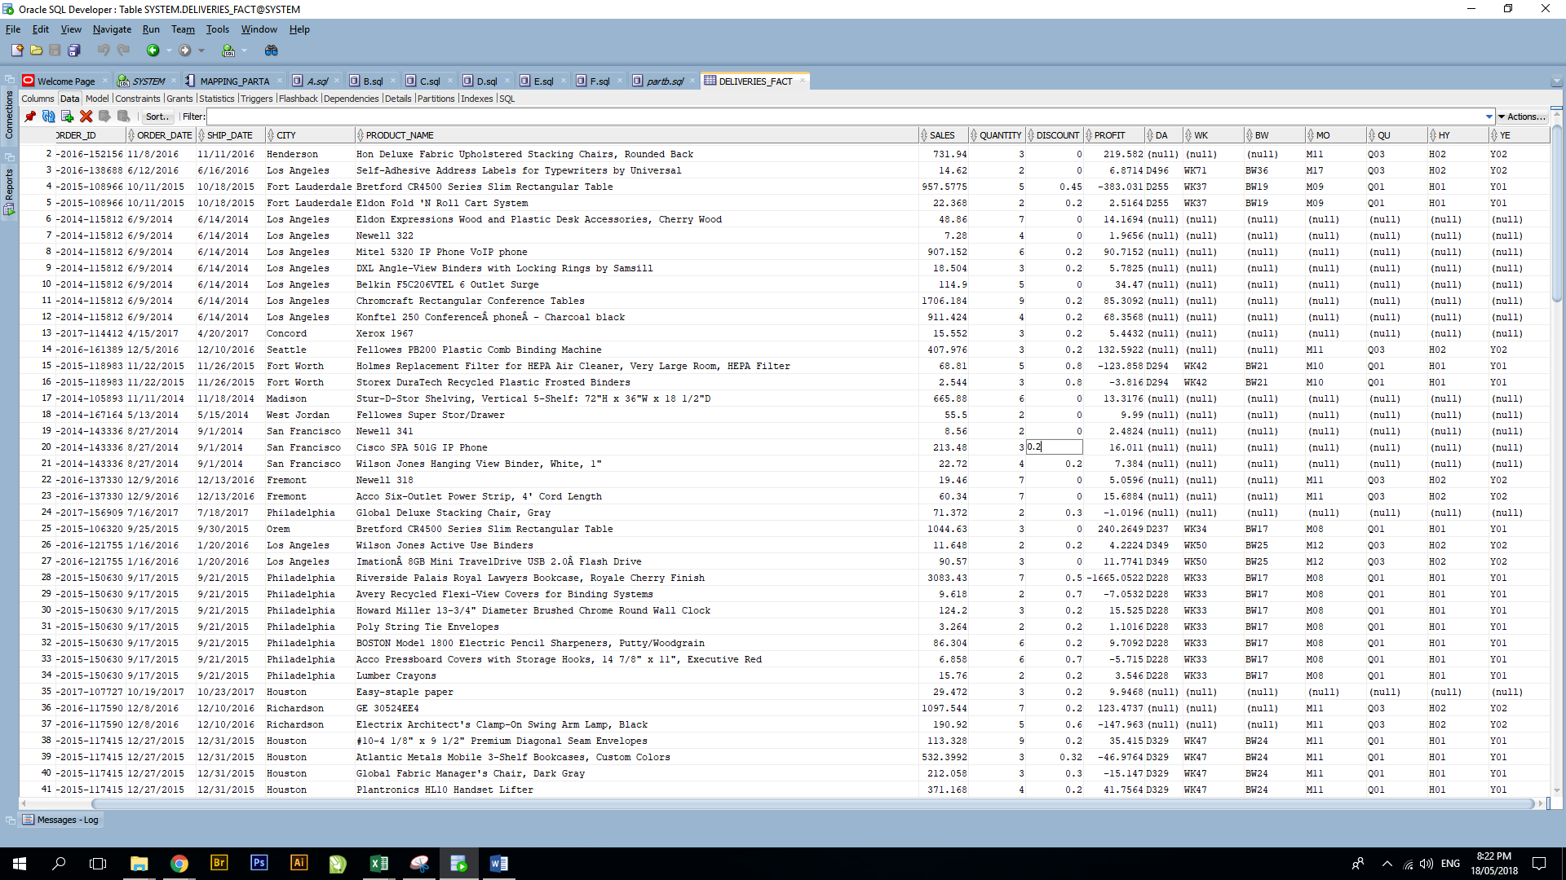

A: SUM OF SALES

SELECT SUM(SALES)

FROM DELIVERIES_FACT

WHERE CITY='Los Angeles' AND ORDER_DATE LIKE '%2015' AND SHIP_DATE LIKE '%2015';

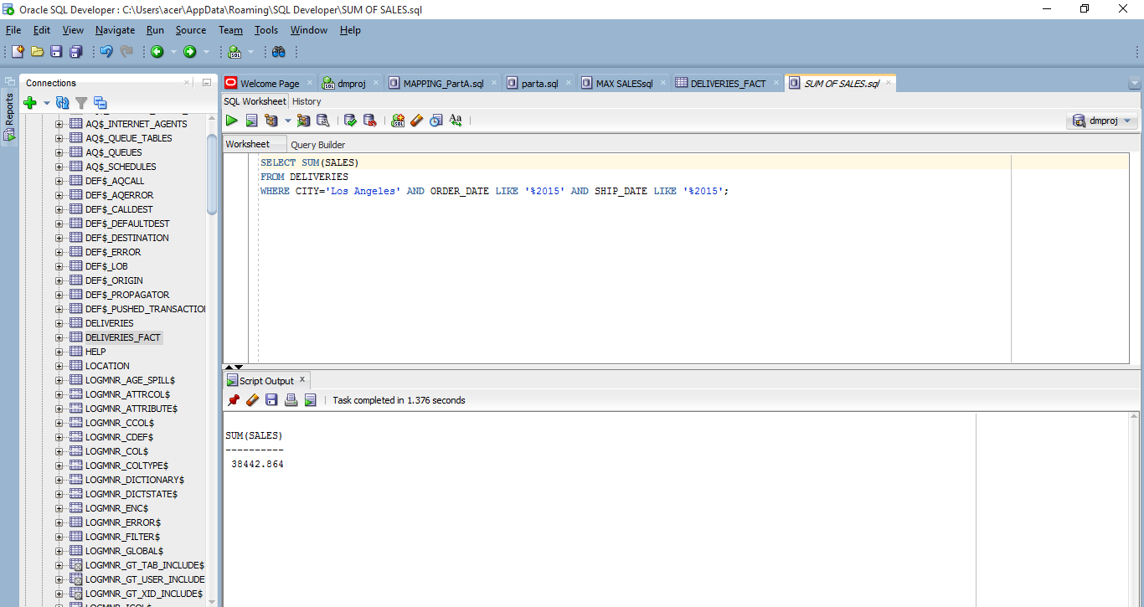

B:

DROP TABLE LETTERB;

create table LETTERB AS

(

SELECT DEL.ROW_ID, DEL.ORDER_ID, DEL.ORDER_DATE, DEL.SHIP_DATE,

DEL.CITY AS LOCATION,

DEL.PRODUCT_NAME,

DEL.SALES, DEL.QUANTITY, DEL.DISCOUNT,DEL.PROFIT,

OTD.TIME_KEY,

OTD.PARENT_ID,

OTD.TIME_DESC

FROM DELIVERIES DEL

RIGHT OUTER JOIN OSS_TIME_DIM OTD

ON

DEL.SHIP_DATE = OTD.TIME_DESC

);

DROP TABLE LET_B;

CREATE TABLE LET_B AS

SELECT PARENT_ID AS MON, SUM(SALES) AS TOTAL_SALES FROM LETTERB WHERE (SHIP_DATE LIKE '%2015' AND PARENT_ID LIKE 'M%') GROUP BY PARENT_ID;

SELECT MON,OTD.TIME_DESC, TOTAL_SALES FROM LET_B B1

FULL OUTER JOIN OSS_TIME_DIM OTD

ON B1.MON= OTD.TIME_KEY

WHERE TOTAL_SALES=(SELECT MAX(TOTAL_SALES) FROM LET_B);

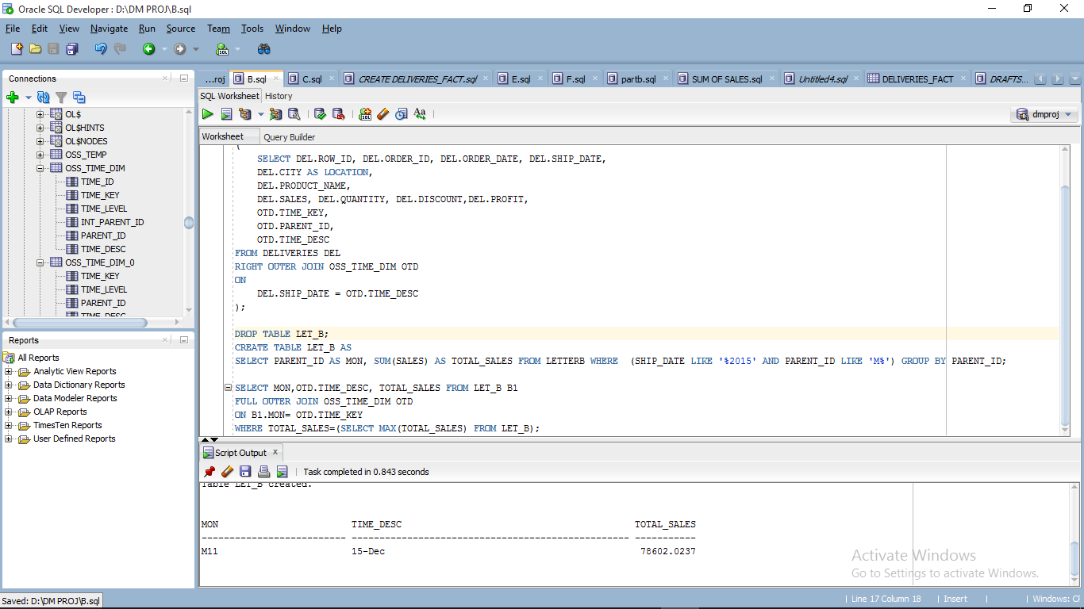

C.

DROP TABLE LETTERC;

create table LETTERC AS

(

SELECT DEL.ROW_ID, DEL.ORDER_ID, DEL.ORDER_DATE, DEL.SHIP_DATE,

DEL.CITY AS LOCATION,

DEL.PRODUCT_NAME,

DEL.SALES, DEL.QUANTITY, DEL.DISCOUNT,DEL.PROFIT,

OTD.TIME_KEY,

OTD.PARENT_ID,

OTD.TIME_DESC

FROM DELIVERIES DEL

RIGHT OUTER JOIN OSS_TIME_DIM OTD

ON

DEL.SHIP_DATE = OTD.TIME_DESC

);

DROP TABLE LET_C;

CREATE TABLE LET_C AS

SELECT PARENT_ID AS MON, SUM(PROFIT) AS TOTAL_PROFIT FROM LETTERC WHERE (SHIP_DATE LIKE '%2015' AND PARENT_ID LIKE 'M%') GROUP BY PARENT_ID ORDER BY TOTAL_PROFIT DESC;

SELECT * FROM LET_C;

SELECT * FROM(

SELECT MON,OTD.TIME_DESC, C1.TOTAL_PROFIT AS TOTAL_PROFIT FROM

(LET_C C1 LEFT OUTER JOIN OSS_TIME_DIM OTD

ON C1.MON= OTD.TIME_KEY)

ORDER BY TOTAL_PROFIT DESC

)WHERE ROWNUM <=3; 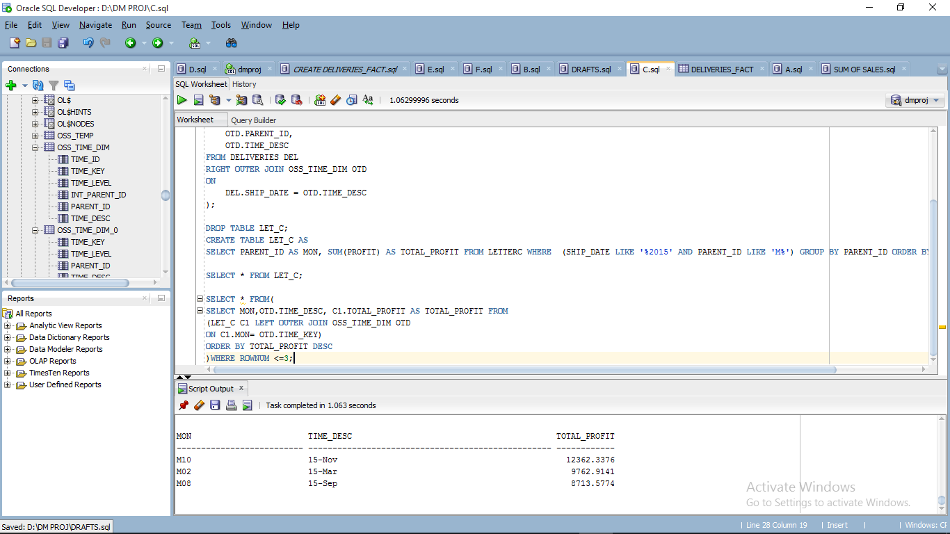

D.

DROP TABLE LETTERD;

create table LETTERD AS

(

SELECT DEL.ROW_ID, DEL.ORDER_ID, DEL.ORDER_DATE, DEL.SHIP_DATE,

DEL.CITY AS LOCATION,

DEL.PRODUCT_NAME,

DEL.SALES, DEL.QUANTITY, DEL.DISCOUNT,DEL.PROFIT,

OTD.TIME_KEY,

OTD.PARENT_ID,

OTD.TIME_DESC

FROM DELIVERIES DEL

RIGHT OUTER JOIN OSS_TIME_DIM OTD

ON

DEL.SHIP_DATE = OTD.TIME_DESC

);

DROP TABLE LET_D;

CREATE TABLE LET_D AS

SELECT PARENT_ID AS MON, PRODUCT_NAME, SUM(QUANTITY) AS QTY_SOLD FROM LETTERD WHERE (SHIP_DATE LIKE '%2015' AND PARENT_ID LIKE 'M%' AND LOCATION='New York City') GROUP BY PRODUCT_NAME,PARENT_ID ORDER BY QTY_SOLD, MON DESC;

SELECT OTD.TIME_DESC as MONTH_,D1.PRODUCT_NAME, D1.QTY_SOLD AS QTY_SOLD FROM

(LET_D D1 LEFT OUTER JOIN OSS_TIME_DIM OTD

ON D1.MON= OTD.TIME_KEY);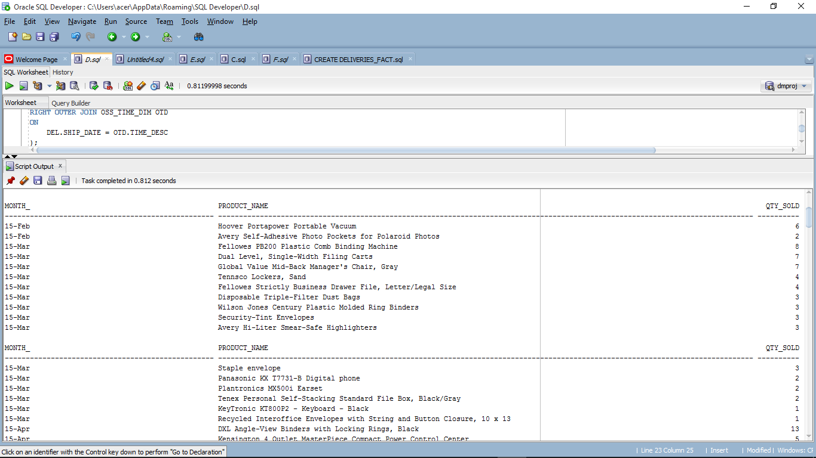

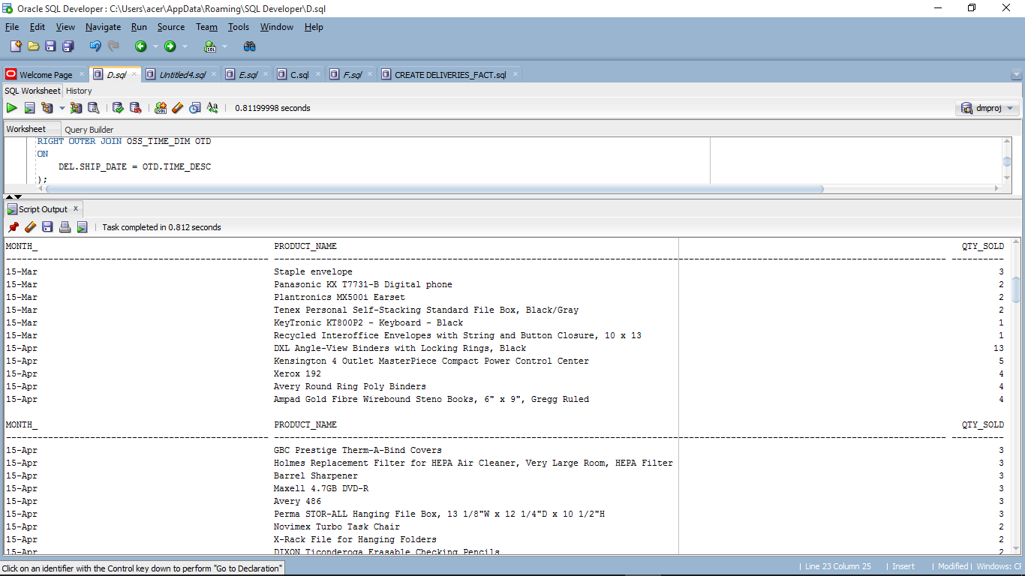

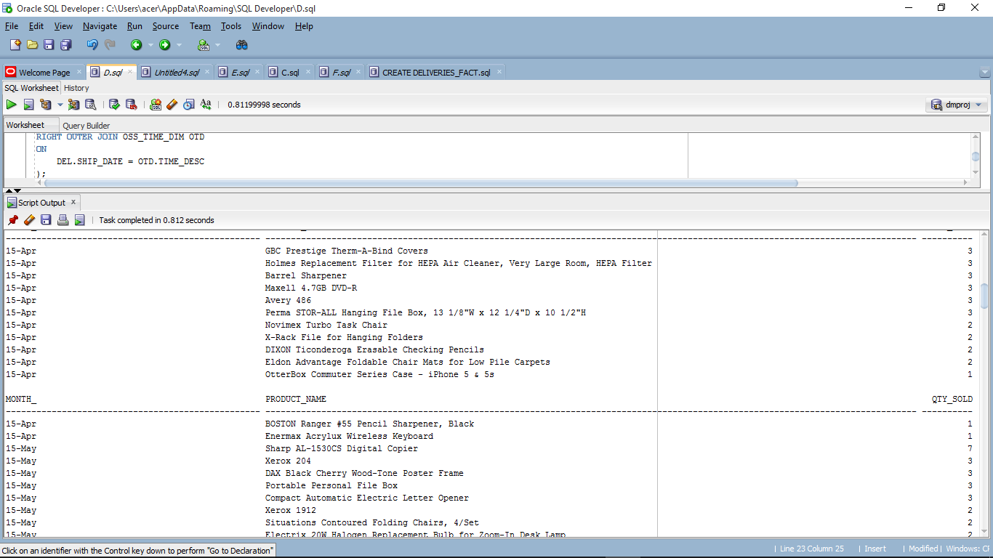

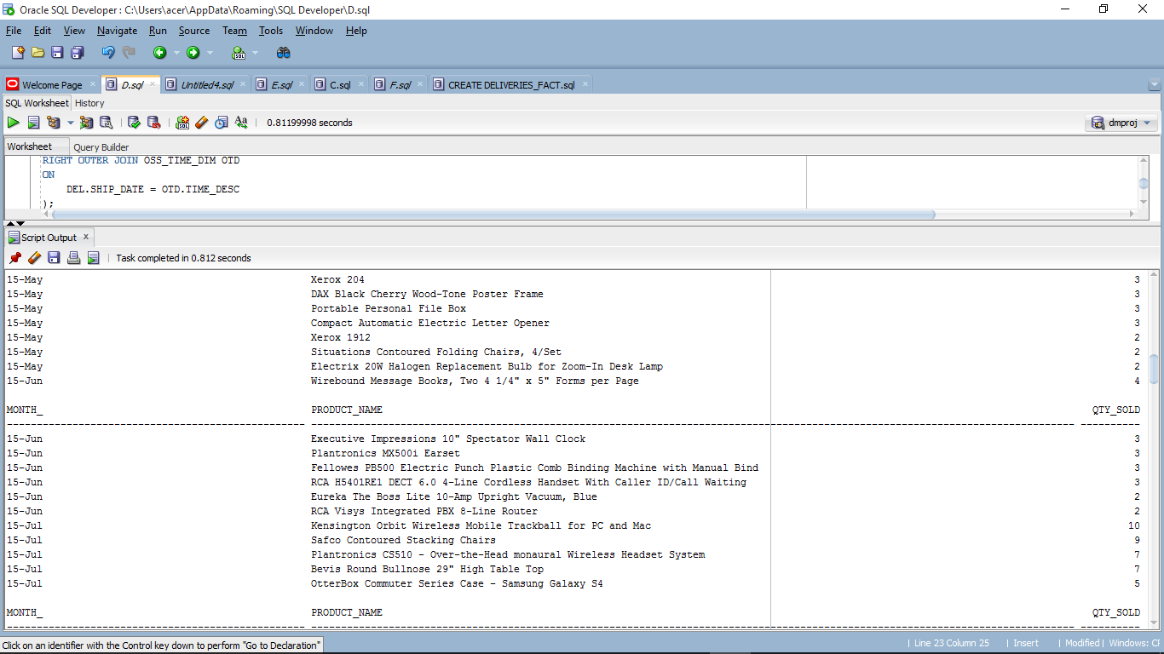

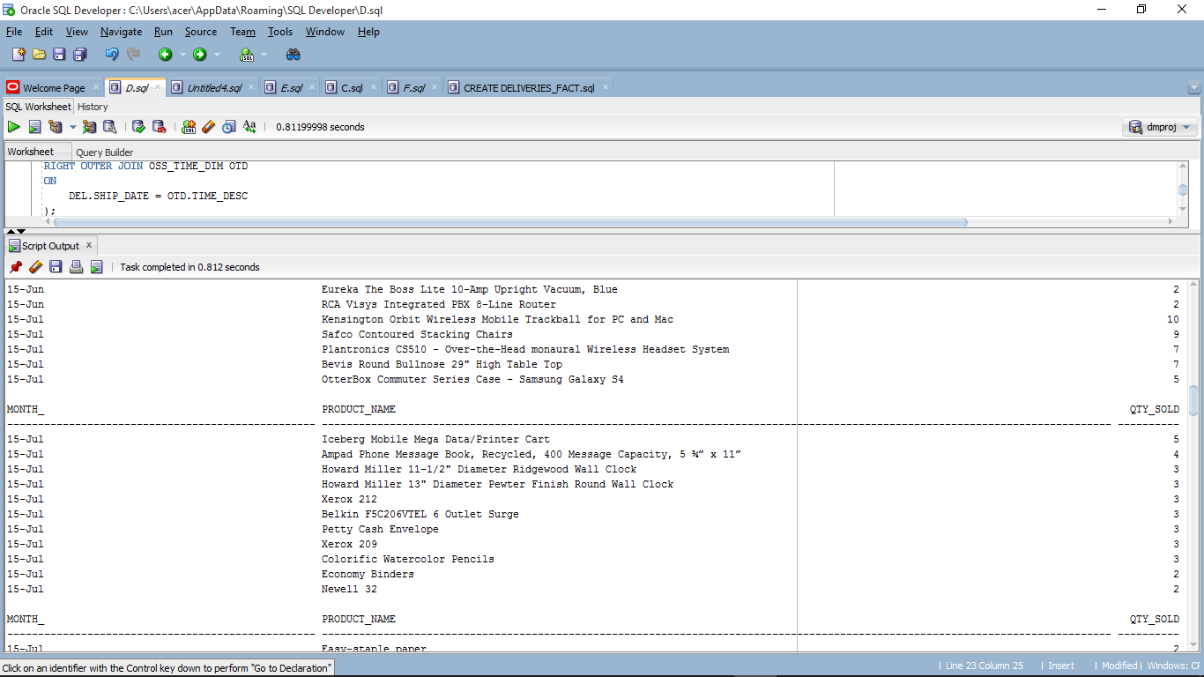

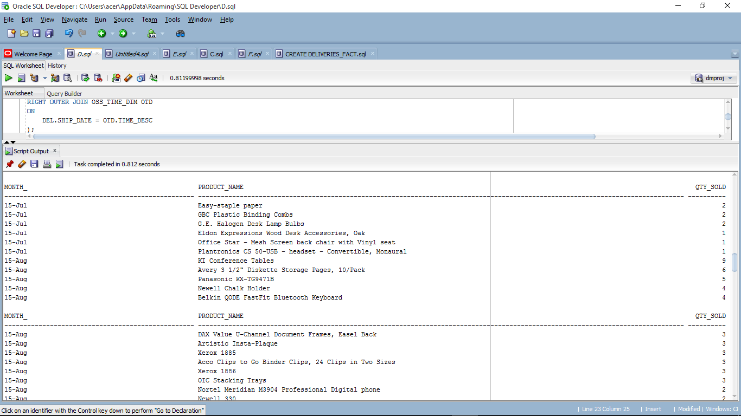

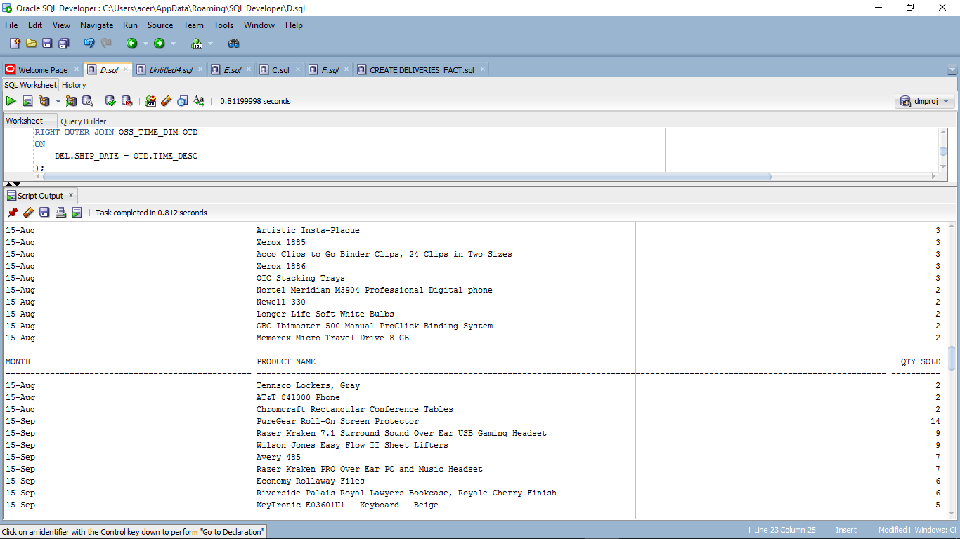

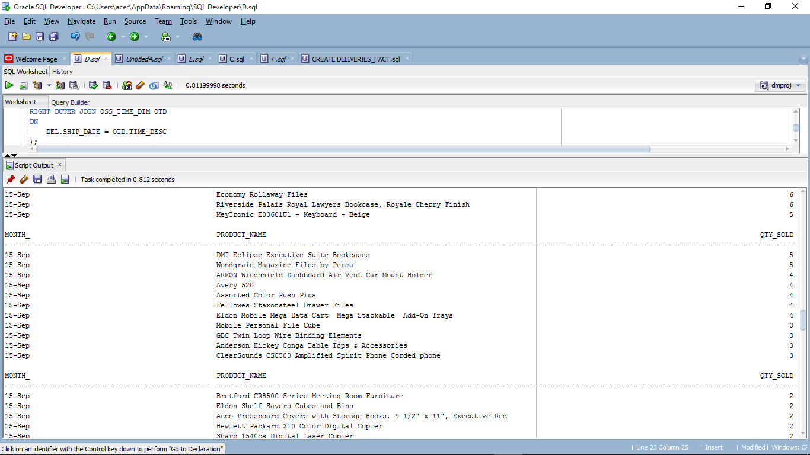

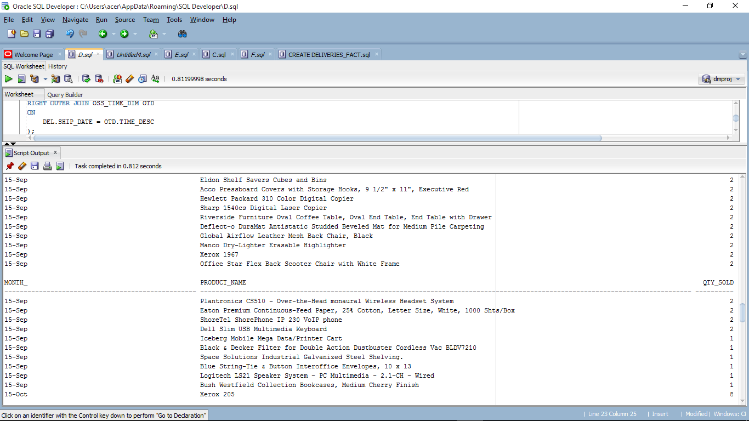

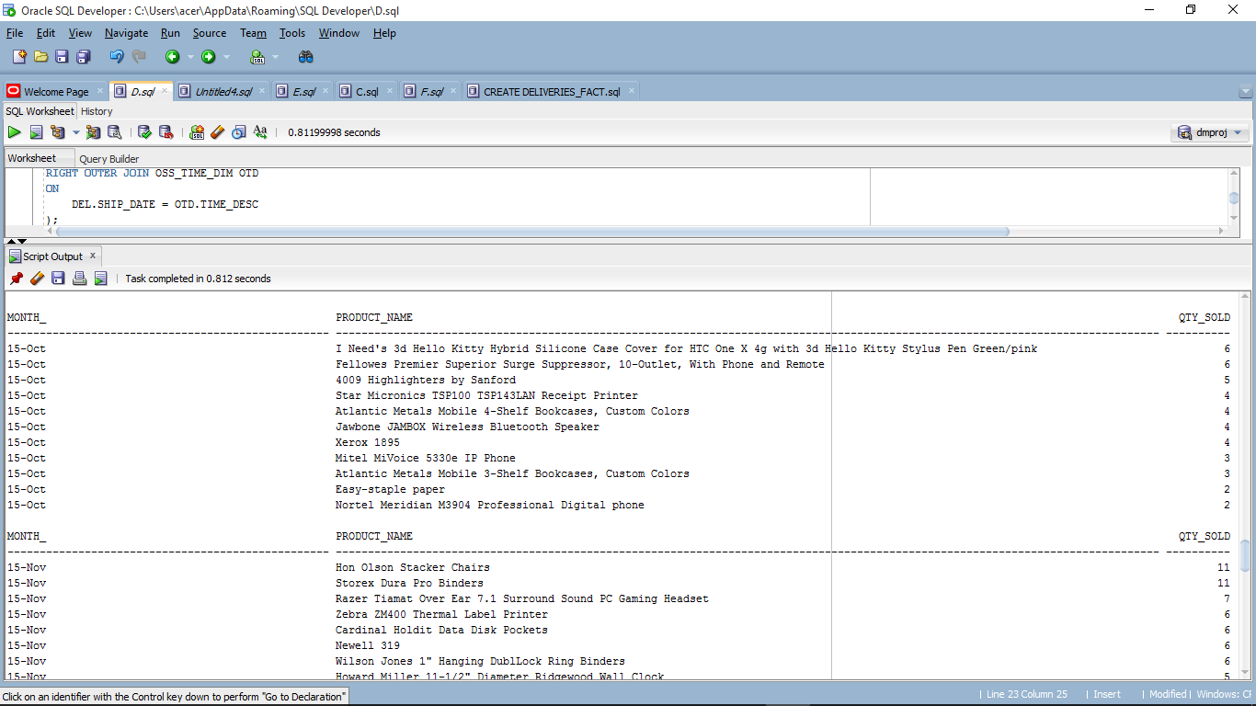

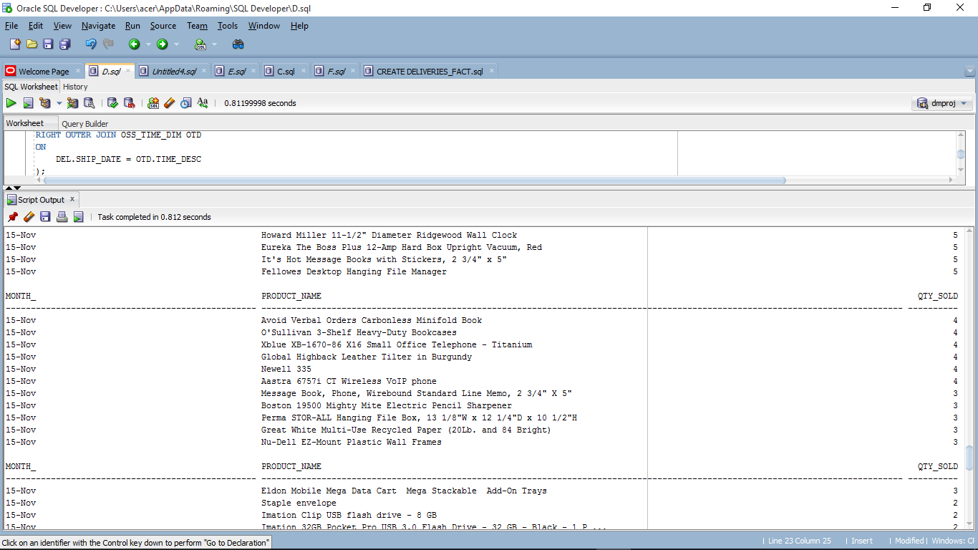

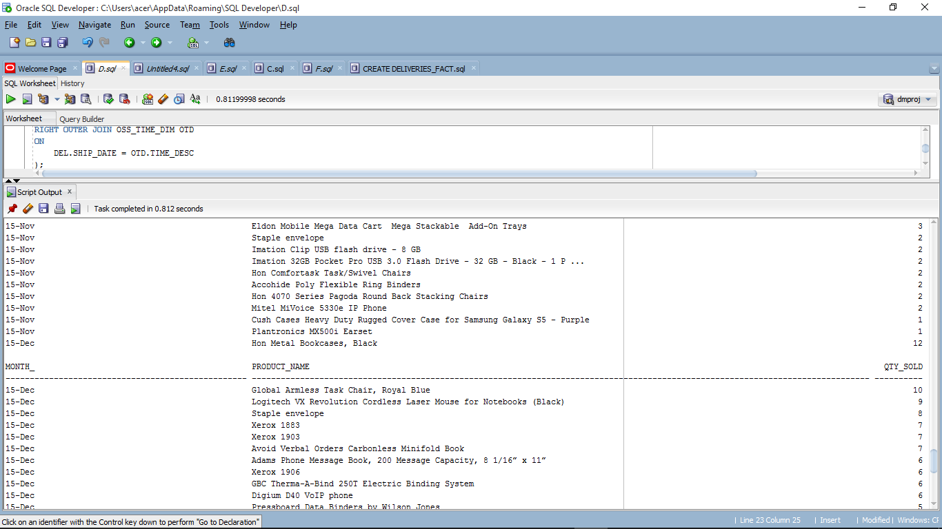

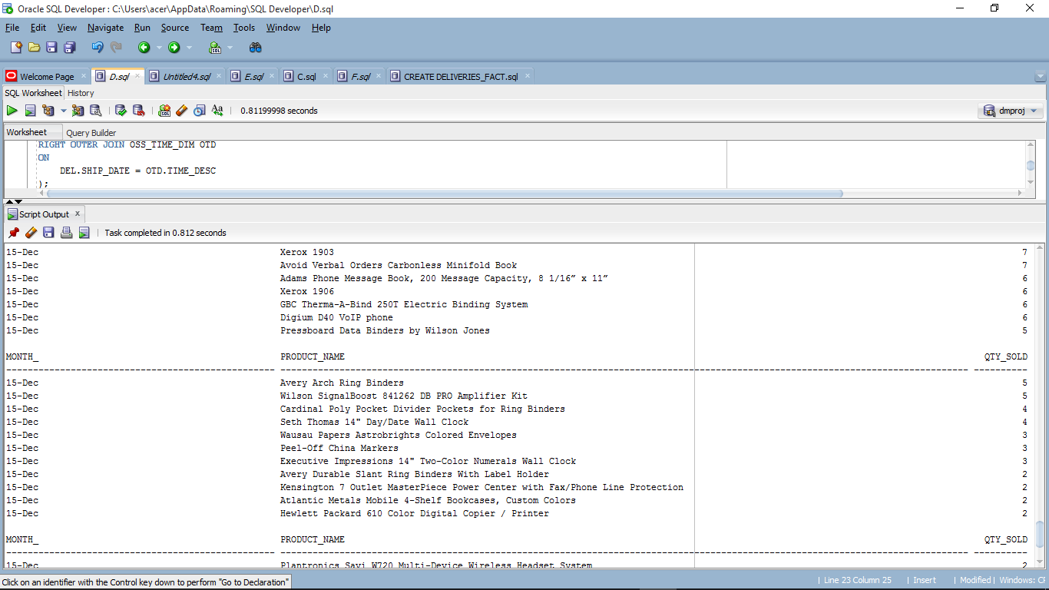

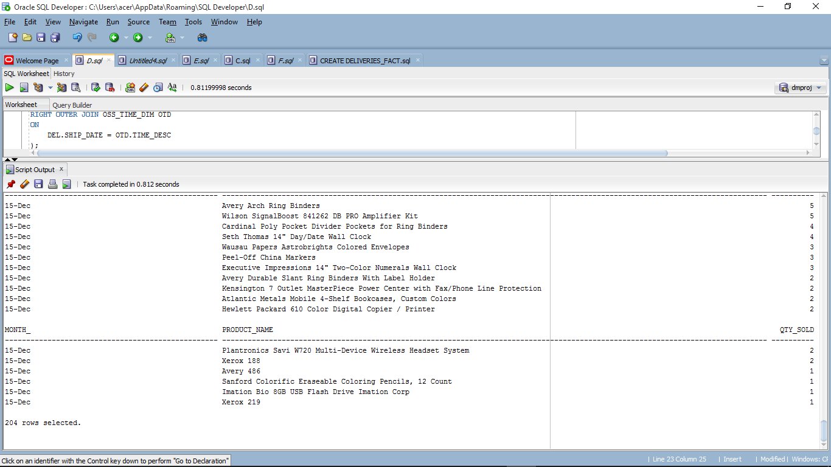

E.

DROP TABLE LETTERE;

create table LETTERE AS

(

SELECT DEL.ROW_ID, DEL.ORDER_ID, DEL.ORDER_DATE, DEL.SHIP_DATE,

DEL.CITY AS LOCATION,

DEL.PRODUCT_NAME,

DEL.SALES, DEL.QUANTITY, DEL.DISCOUNT,DEL.PROFIT,

OTD.TIME_KEY,

OTD.PARENT_ID,

OTD.TIME_DESC

FROM DELIVERIES DEL

RIGHT OUTER JOIN OSS_TIME_DIM OTD

ON

DEL.SHIP_DATE = OTD.TIME_DESC

);

DROP TABLE LET_E;

CREATE TABLE LET_E AS

SELECT PARENT_ID AS MON, PRODUCT_NAME, SUM(QUANTITY) AS QTY_SOLD_SALES,SUM(PROFIT) AS PROFIT_GENERATED FROM LETTERE WHERE (SHIP_DATE LIKE '%2015' AND PARENT_ID LIKE 'M%') GROUP BY PRODUCT_NAME,PARENT_ID ORDER BY PROFIT_GENERATED DESC;

DROP TABLE LET_E2;

CREATE TABLE LET_E2 AS(

SELECT OTD.PARENT_ID AS QUARTER,E1.PRODUCT_NAME, (E1.QTY_SOLD_SALES) AS QTY_SOLD_SALES, (E1.PROFIT_GENERATED) AS PROFIT_GENERATED FROM

(LET_E E1 LEFT OUTER JOIN OSS_TIME_DIM OTD

ON E1.MON= OTD.TIME_KEY)

);

SELECT * FROM(

SELECT QUARTER, PRODUCT_NAME, SUM(QTY_SOLD_SALES) AS QTY_SOLD_SALES, SUM(PROFIT_GENERATED) AS PROFIT_GENERATED

FROM LET_E2

WHERE QUARTER='Q01'

GROUP BY PRODUCT_NAME,QUARTER ORDER BY QUARTER

)WHERE ROWNUM <=3

UNION

SELECT * FROM(

SELECT QUARTER, PRODUCT_NAME, SUM(QTY_SOLD_SALES) AS QTY_SOLD_SALES, SUM(PROFIT_GENERATED) AS PROFIT_GENERATED

FROM LET_E2

WHERE QUARTER='Q02'

GROUP BY PRODUCT_NAME,QUARTER ORDER BY QUARTER

)WHERE ROWNUM <=3

UNION

SELECT * FROM(

SELECT QUARTER, PRODUCT_NAME, SUM(QTY_SOLD_SALES) AS QTY_SOLD_SALES, SUM(PROFIT_GENERATED) AS PROFIT_GENERATED

FROM LET_E2

WHERE QUARTER='Q03'

GROUP BY PRODUCT_NAME,QUARTER ORDER BY QUARTER

)WHERE ROWNUM <=3

UNION

SELECT * FROM(

SELECT QUARTER, PRODUCT_NAME, SUM(QTY_SOLD_SALES) AS QTY_SOLD_SALES, SUM(PROFIT_GENERATED) AS PROFIT_GENERATED

FROM LET_E2

WHERE QUARTER='Q04'

GROUP BY PRODUCT_NAME,QUARTER ORDER BY QUARTER

)WHERE ROWNUM <=3

;

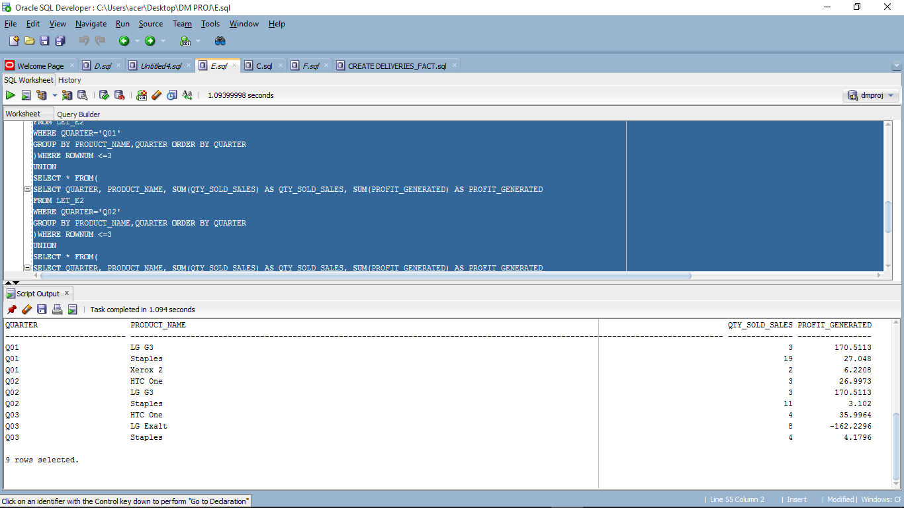

F.

DROP TABLE LETTERF;

create table LETTERF AS

(

SELECT DEL.ROW_ID, DEL.ORDER_ID, DEL.ORDER_DATE, DEL.SHIP_DATE,

DEL.CITY,

DEL.PRODUCT_NAME,

DEL.SALES, DEL.QUANTITY, DEL.DISCOUNT,DEL.PROFIT,

OTD.TIME_KEY,

OTD.PARENT_ID,

OTD.TIME_DESC

FROM DELIVERIES DEL

RIGHT OUTER JOIN OSS_TIME_DIM OTD

ON

DEL.SHIP_DATE = OTD.TIME_DESC

);

DROP TABLE LET_F;

CREATE TABLE LET_F AS

SELECT PARENT_ID AS MON, PRODUCT_NAME,CITY, SUM(QUANTITY) AS QTY_SOLD_SALES FROM LETTERF WHERE (SHIP_DATE LIKE '%2015' AND PARENT_ID LIKE 'M%') GROUP BY CITY,PRODUCT_NAME,PARENT_ID,QUANTITY ORDER BY QTY_SOLD_SALES DESC;

DROP TABLE LET_F2;

CREATE TABLE LET_F2 AS(

SELECT OTD.PARENT_ID AS QUARTER,F1.PRODUCT_NAME, CITY,(F1.QTY_SOLD_SALES) AS QTY_SOLD_SALES FROM

LET_F F1 LEFT OUTER JOIN OSS_TIME_DIM OTD

ON F1.MON= OTD.TIME_KEY)

;

SELECT * FROM(

SELECT QUARTER, CITY AS LOCATION, SUM(QTY_SOLD_SALES) AS QTY_SOLD

FROM LET_F2

WHERE QUARTER='Q02'

GROUP BY PRODUCT_NAME,QUARTER,CITY ORDER BY QTY_SOLD DESC

)WHERE ROWNUM <=1

UNION

SELECT * FROM(

SELECT QUARTER, CITY AS LOCATION, SUM(QTY_SOLD_SALES) AS QTY_SOLD

FROM LET_F2

WHERE QUARTER='Q03'

GROUP BY PRODUCT_NAME,QUARTER,CITY ORDER BY QTY_SOLD DESC

)WHERE ROWNUM <=1

;

